Result
The information of the CV:
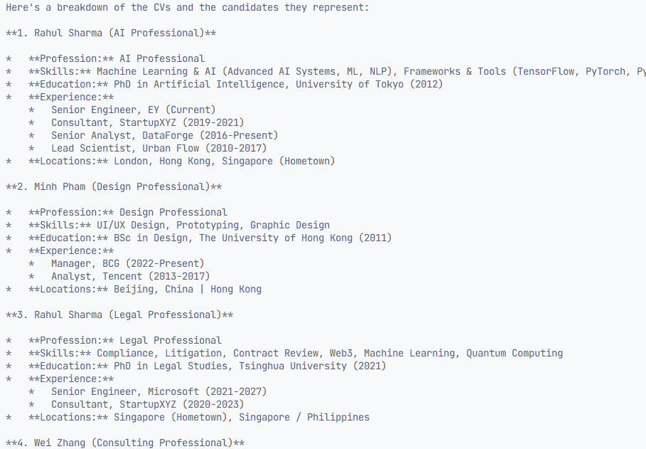
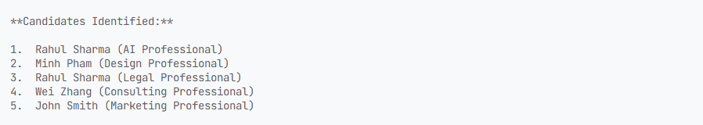

Calling MCP:
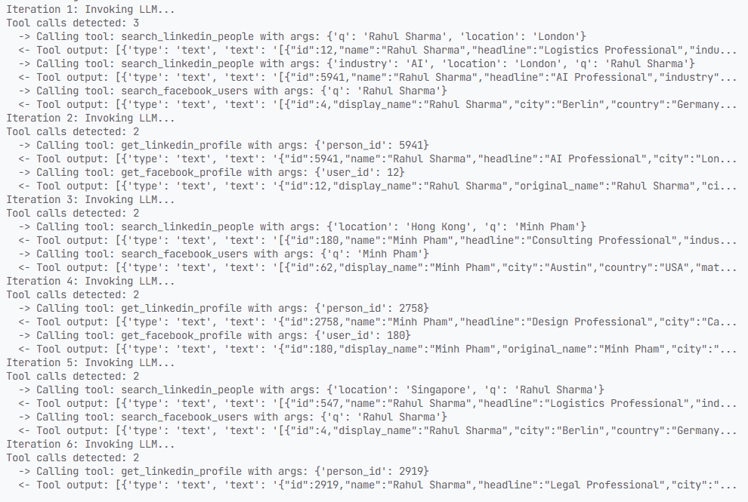
Verification Reports and Scores:
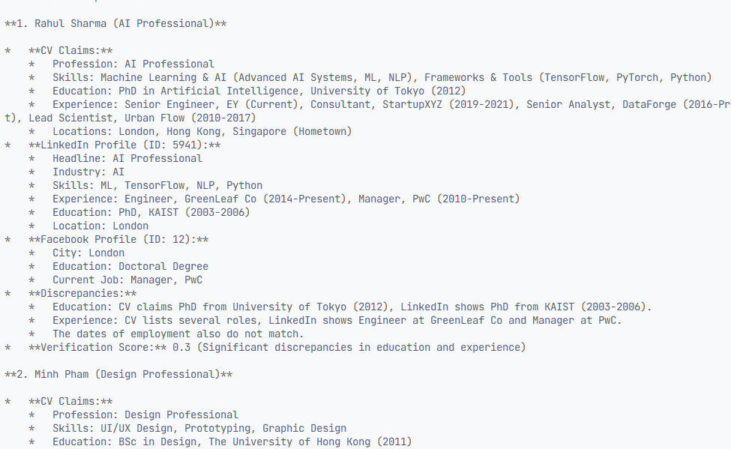

Test
1.When test the code,please change line 31 to your api.
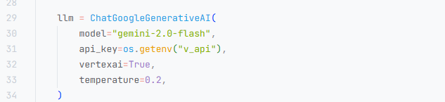
2.Put all CVs into cv directory,and the agent will indentify them.
3.If more CV need to be verificated,please change the turns in line 115.In avreage,each CV may need 4 turns.
